

**PRESS RELEASE** Prague, 14th November 2016

**PASSERINVEST GROUP successfully completes acquisition of two more buildings in BB Centrum**

**The leading Czech development and investment company PASSERINVEST GROUP successfully completed the acquisition of two office buildings in Prague’s BB Centrum, Buildings A and B. PASSERINVEST GROUP acquired the modern office buildings situated along the main Vyskočilova Avenue by buying them from IMMOFINANZ. The financing bank was UniCredit Bank Czech Republic and Slovakia, a.s.**

In accordance with its long-term strategy, PASSERINVEST GROUP has already bought two buildings back for its portfolio: the ALPHA Building in 2014 and the BETA Building in 2015. The modern office Building A, with eight storeys and four underground levels, was completed in 2002 and was the third building to be finished in the multifunctional BB Centrum complex. The authors of the project are the architects Martin Krupauer and Jiří Střítecký from Atelier 8000 and the general contractor was PSJ, a.s. Building A has a total of 21 000 m2 of offices and 887 m2 of retail space to rent and it has 400 parking spots on the underground levels. An effective element of the building is the internal atrium. The south façade with the main front is designed with curtain glass cladding and it guarantees a high degree of protection of the office spaces against noise and heat leaks.

Building B is one of the first projects completed in BB Centrum. This administrative building with eight storeys and three underground levels was the second building to be completed in the complex in 1999. It offers 16 500 m2 of leasable space and 280 underground parking spots. The Building B project comes from the architectural studio of Aulík Fišer architekti and the general contractor was PSJ, a.s. Just like the other buildings in BB Centrum, Building B is also very flexible and user friendly. The operationally very efficient glazed double south façade is an interesting feature. The building is currently the headquarters of MONETA Money Bank.

PASSERINVEST GROUP counts on the extensive revitalisation of both of the buildings with the goal of modernising the technology according to the latest trends and to perform and interior and exterior facelift of the buildings. Thanks to these considerable investments into the modernisation of both of the buildings, the offer of prime office and retail space in the very centre of BB Centrum will grow. “Our vision is to maintain the utmost quality in the leased spaces of all the BB Centrum buildings and to create an interesting product, primarily for long-term investors, while building a living and functioning urban neighbourhood with all of its attributes,” added Radim Passer, the Chairman of the Board and General Director of PASSERINVEST GROUP, a. s.

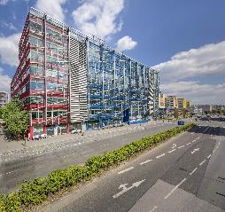

Building A

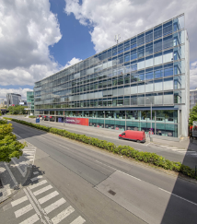

Building B

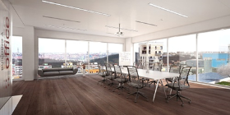

New office space on Building A - visualization

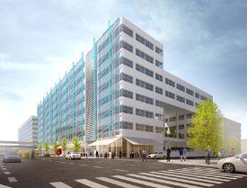

New appearance of Buildings A and commercial premises

For more information and photographs in print quality please contact:

Kristýna Samková**,** Head of Marketing and PR dept.

**PASSERINVEST GROUP, a.s.**

Tel.: (+420) 221 582 111

Mobil: (+420) 602 186 708

E-mail: [Kristyna.Samkova@Passerinvest.cz](mailto:Kristyna.Samkova@Passerinvest.cz)

www.passerinvest.cz, [www.bbcentrum.cz](http://www.bbcentrum.cz)

Marcela Štefcová

**Crest Communications a.s.**

Tel.: (+420) 222 927 125

Mobil: (+420) 731 613 669

E-mail: marcela.stefcova@crestcom.cz

**About the Developer**

**PASSERINVEST GROUP, a.s.,** founded in 1991 by Radim Passer, is a purely Czech development and investment company whose name is associated in particular with the **BB Centrum** multifunctional complex in Prague 4 - Michle. With this project, the most successful and extensive Czech project of its type, the company has built its excellent reputation both at home and at the international level. Contributing to this is not only the high quality of the projects completed to date, but also its high level of service, its sense of fair play, its positive relationship with the tenants and users of its buildings, and its sense of responsibility towards society and the environment. **PASSERINVEST GROUP**’sportfolioincludes other interesting development projects.